ATTITUDE MATTERS
(Text of speech delivered by Justice Yatindra Singh on 2nd of October 2011 on the prize distribution function of the first All-India bilingual essay competition on 'Education and Nation Building' organised by Sanwal Das Sadan Lal Khanna Girls' Degree college Allahabad.
Summary: Education is important; so is attitude. Nowadays, when education is overemphasised in our country, it is relevant to know what other things are important in life)
नमस्ते
A very good evening to all of you.

This is the inaugural year of the national level bi-lingual essay competition to be organised by the college every year. The topic chosen for this year is 'Education and Nation Building'. So, why did I choose to speak on 'Attitude' today. Let me tell you the reason first.

About a decade ago I attended a convocation at IIT Kanpur, when my son was getting B.Tech. degree as well as an award. In the convocation a magazine was distributed. It contained some information about the students.

IIT's follow the American pattern: they rely heavily on their alumni. They also hold alumni meet every year, especially inviting students, who had passed out 25 years ago and best alumnus award is also given to the most illustrious among those, who passed out 25 years ago.

The information in the magazine contained the names of the most illustrious alumnus of different years; the highest rank of the student of that batch in the joint entrance examination of the IITs and the President's award winner of that batch. These three names were different.

The most illustrious alumnus was neither the person who had secured the highest rank in the entrance examination nor the person who had got President's award but was a third person. What is the reason for this?

The reason is the difference in the 'Attitude'. It is—if not more—then at least equally important as education in life. It is rightly said,
'Attitude, not aptitude, determines altitude.'

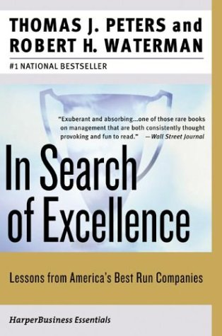
In early 1980's Thomas J. Peters and Robert H. Waterman wrote a book titled ‘In Search of Excellence'. It went on to become an international best seller. The book talks about lessons from best American companies. The authors pose a question as to how these companies grew the way they are and then answered:
‘A strong leader ... have had a lot to do with making the company excellent in the first place. ...
The excellent companies seem to have developed cultures that have incorporated the values and practices of the great leaders. ... the real role of the chief executive is to manage the values of the organization.' (See Endnote-2)
So is the case with nation building.

We require inspiring and strong leaders for nation building. Mahatma Gandhi, whose birthday we celebrate today, was undoubtedly one and he inspired the nation.

One great quality of Gandhi was—he practised what he preached. Perhaps, what we lacked was, better incorporation of his values in our lives: we should do it. Perhaps, we require another Gandhi to inspire us.

But what makes a person an inspirational figure; what attitude leads to success? Let me talk about some of them.

HAVE CONFIDENCE, BE OPEN, AND ACCEPT YOUR MISTAKES
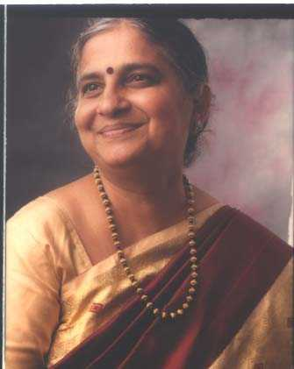
There was an engineer girl, who saw an advertisement of TELCO (now TATA Motors). It advertised only men engineers need apply. She was told the reason: women might not be able to stand the heat of the hot furnaces.

The girl protested and wrote a letter to Telco. To their greatness, Telco took her in their fold despite their advertisement. She continued there till she along with her husband decided to make their own company from the money that was generated from the girl's jewellery. The company they made, went on to put India on the World map. Her name was Sudha Murthy and the company that they formed - Infosys.

You must have confidence in yourself and the contribution of Telco cannot be undermined: despite their advertisement, they were open, they realised their mistake, and accepted Sudha Murthy.

DO WHAT YOU ENJOY
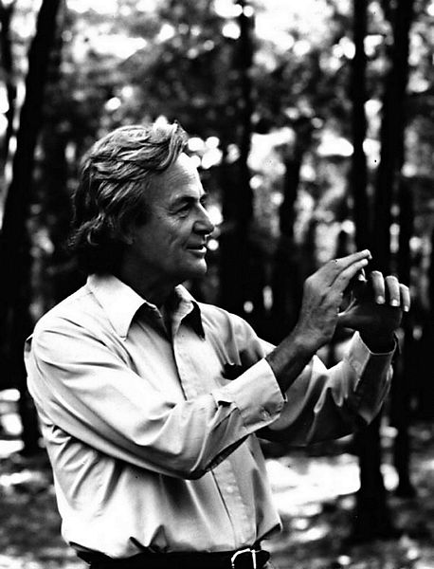
The Riverside Church stands next to the Hudson river in New York. It is the tallest church of the United State as well as has the world's largest tuned carillon bell. It also received New York City Landmark status in 2000.

The façade of the church is decorated with the sculptures of leading personalities in different fields. Some of them are of scientists. There was some debate about the names of the scientists to be included there and a poll was taken from the scientists. The names varied but every list included the names of Newton and Einstein. And Einstein was the only living scientist so polled.

This poll was in 1929. Had this poll taken after 50 years then the matter would have been different. It would have included the name of Feynman too: what Einstein was to the first part of the of the last century; Feynman was to the second half—both were most famous scientists of the last century and won Noble prize in Physics.

Feynman, after finishing his graduation from MIT, moved on to Princeton for PhD and then to nuclear laboratory at Los Almos for developing atom bomb during the Second World War. He was in love with a girl from his school days -Arline. They had decided to marry after he got a stable job. Alas, he was still doing his Ph.D, when Arline fell ill.

Arline had TB, a fatal disease those days. She had only few years to live. They could only have a limited physical relationship. Feynman could not even kiss for fear of contracting the disease. He came under enormous pressure from his family and friends not to marry her. Yet, he decided to go ahead with the marriage. She died when he was still at Los Almos

After the war, he had some offers but went to Cornell. The reason was simple. It was where Bethe worked. They had got along well at Los Almos.

One day in Cornell's Cafeteria, one of the students was fooling around. He threw a plate into the air, spinning it like a Frisbee; it wobbled too. The white plate had red medallion of Cornell on it. It made a strange scene The medallion went round at a different rate because of the wobble. Intrigued by the correlation between spinning and wobbling, Feynman went out to calculate the relationship between the two.

The answer was simple; the relationship was 2:1 but the calculation was complex. It took a lot of Feynman's time. His friends and colleagues asked him why was he wasting time on this worthless problem. He said,
'I am doing it for fun. It has no importance.'
But Feynman was wrong.

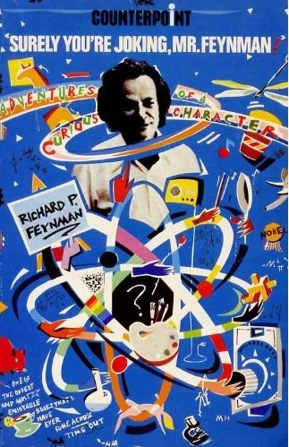
Feynman was stuck with the problem of the spinning of electrons. He remembered about the mathematics and the equation with which he had dabbled while calculating the relationship between spin and wobble of the plate. He started looking into his problem with his old insight. This contributed to his theory, which won him the Nobel Prize.

The best thing in life is to make your hobby, your profession. If this cannot be done then make your profession as enjoyable as your hobby.

DIFFERENCE LIES IN THINKING
Akio Morita and Ibuka were co-founders of 'Sony' that changed the image of 'Made in Japan': from notation of 'cheep imitation' to one associated with the 'World quality'.

One day, Morita saw Ibuka with a portable stereo tape recorder and a pair of head phones. When he asked Ibuka as to why he was doing it, he answered that he liked to listen to the music but didn't want to disturb anyone else, but also remarked that it was difficult as the music system was too big.

Morita thought of his children, who would rush to their rooms to listen to music as soon as they entered home. He had also seen many Japanese carrying heavy music players on their shoulders. He started playing with the idea of making small music system that could be carried anywhere.

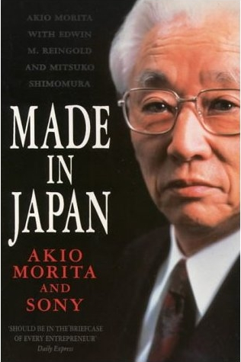
The Sony used to market a small cassette tape recorder called pressman. Morita called his engineers and asked them to strip out the recording circuit as well as the speakers from it and asked them to make a very light headphone to listen to the music. No one thought it to be a good idea. His engineers, sales men were pessimistic: who will buy, if it does not have recording capability?

The project was only undertaken when Morita took personal responsibility for it. This is how the walkman came to the market in 1979. It went on to become most successful selling item of all times. Sony sold more than 220 million (22 crores) different models of walkman till 2010 when its production ended giving way to new generations of walkman in shape of iPods and mobile phones.

HAVE FAITH IN YOURSELF
In 1913 Godfrey Harold Hardy was 36 years of age and was an established mathematician. He belonged to the field of pure mathematics. He was already a Fellow of the Royal Society and was with the Cambridge University. His name appeared not only in every Mathematical Journal of that time but also in the journal of Medicine. He had propounded Hardy-Weinberg law, which states,
‘Dominant traits will not take over and recessive traits will not die out.'
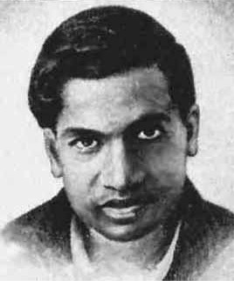
Hardy's future was secure and life fixed. Then it all changed by a letter from India, by an unknown person named Srinivas Ramanujan. The letter was as follows:
‘Sir,
I beg to introduce myself as a clerk in the Accounts Department... on a salary of £ 20 per annum... I have no University education... I have not trodden through the conventional regular course... but I am striking out a new path myself. I have made special investigation... and the results... are termed as startling by local mathematicians’.
And then Ramanujan had rattled off some of his results. Hardy had never seen anything of this kind. He was excited (see Endnote-3). It is then as Hardy would say later,
‘The romantic incident of my life began'.

Hardy was once asked what was his greatest discovery. His answer was—Ramanujan. But he also added,
‘I did not invent him [Ramanujam]. Like other great men, he invented himself.’

‘A mathematician's apology’ is a classic. It was written at the end of Hardy's life. He offered explanation for irrelevance of pure mathematicians to a common man's need. In the book, he consoled himself.
‘I have done one thing... (that pompous people) have never done... (It) is to have collaborated with... Ramanujan on something like equal terms.’

Ramanujan was original. He proved many theorems that were already proved but in his own way as he never read them formally; he in fact rediscovered them.

Ramanujan was intuitive. Many of his theorem were not proved and Hardy later said that he spent rest of his life proving or disproving them.
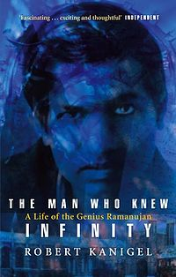
In England, Ramanujan fell ill and was admitted in a hospital. Hardy would visit him on weekends. On one of his visits, Hardy noticed the Taxi number; it was 1729. On reaching the hospital he wondered if it was a dull number and being multiple of thirteen (13x133) could be a bad omen. Ramanujam's pat reply was,
'No, it is a very interesting number. It is the smallest number, which can be expressed as the sum of two cubes in two different ways. 1729 is equal to 12³ +1³ and 10³+9³.'

Ramanujan was confident. He came from an ordinary background; he had not studied Mathematics in the conventional way, yet was confident of his work. It is for this, that he wrote,
'I am striking a new path for myself.'
Have faith in yourself.

I hope this will not be just an essay competition but will inspire you to be good citizens and help in building India so that we may change the second last word of the song - from होंगे to हैं
'सुनो गौर से दुनिया वालो,
बुरी नज़र न हम पर डालो।
चाहे जितना जोर लगालो,
सबसे आगे होंगे हिन्दुस्तानी।'

Endnote-1: The incidents regarding Feynman, Akio Morita, and Ramnujan are from the following books. These books are good and are worth reading.
- Surely you’re Joking, Mr. Feynman! by Richard Feynman and Ralph Leighton; Richard Feynman;
- Richard Feynman: A life in Science by John Gribbin and Mary Gribbin; published by Penguin Books;
- Made in Japan: An Autobiography of Morita;
- The Man Who Knew Infinity: A Life of the Genius Ramanujan by Robert Kanigel.
There is also a movie titled ‘Infinity’ (directed by Matthew Brodevick) based on the earlier part of Feynmann's life upto Arline's death.

Endnote-2: McDonalds and IBM are two of the American companies mentioned in the 'In search of Excellence'. McDonalds was said to have developed culture incorporating the values and practices of serving 'quality product and cleanliness'; whereas IBM was said to have incorporated 'service and reliability'.

Endnote-3: A prime number is a number larger than one that can only be divided by one or itself without leaving any remainder i.e. 2, 3, 5, 7, 11 ... A number that can be so divided by other numbers are known as composite numbers. Prime numbers do not have factors: they are as simple as numbers get. Mathematicians are obsessed with Prime numbers as they are the foundation of all other numbers.

Around 300 BC, Euclid proved that there are infinitely number of prime numbers. There is no known useful formula that yields all of the prime numbers and no composites. No one knows when and where will they occur. If you find one prime number, there is no way to tell where the next one will occur without checking all the numbers as you go.

One possible way is to find out how the prime numbers are distributed is to find how many prime numbers are there less than a given number. This was proposed by Bernhard Riemann in 1858: he proposed a formula (Riemann hypothesis) that would calculate how many primes are there below any given number. It is a kind of a refined statement concerning the distribution of prime numbers. The solution of his hypothesis might end the unpredictability of the prime numbers.

International Congress of Mathematicians is held once in every four year. In 1900, ICM was held in Paris. David Hilbert posed 23 problems for mathematicians to solve. Riemann hypothesis was at number 8 of these questions. Some of them have been resolved, some are partly resolved and some are unresolved. Riemann hypothesis is still unresolved. The Clay Mathematics Institute has offered $1 million award for its successful solution.

In the letter to Hardy, among other things, Ramanujan also referred to a book by Hardy titled 'Orders of Infinity', where Hardy had mentioned that no definite expression has been found for the numbers of prime number less than any given number and said that he (Ramanujan) had found an expression which very nearly approximates to the real result, the error being negligible. Then he had mentioned what he had done in this regard.

This excited Hardy for he thought that Ramanujan could resolve Riemann hypothesis.

Endnote-4: The photographs of Sudha Murthy, Richard Feynman, and Srinivas Ramanujan are from Wikipedia.

