(Text of speech of Justice Yatindra Singh in the Judges' library on 14.12.2011 on the retirement of Justice SK Tripathi)

नमस्ते and good evening to all of you.

Farewell is a bitter-sweet occasion: it is an occasion to share fond memories. If you wish to share or say something about Brother SK Tripathi, then you are welcome.
...
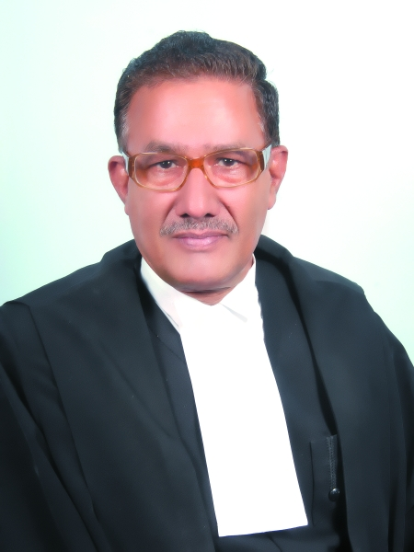
Brother Tripathi joined us in April 2009. During his short span of 2 years and 8 months, he mostly sat on criminal side. Yesterday, when Rafat Bhai requested me to conduct his farewell function, I thought appropriate to ask the criminal side lawyers as to what kind of judge was he. After all, Bar is not only judge of all Judges but perhaps their best judge. I was told,
'Brother Tripathi is intelligent, hard working, punctual, and a gentleman Judge - both in and out side the court. He treated all with same standard—without bias or favour. The best part was that there was never any controversy about him.'
The sentiments that we all long for. I wish the Bar would have the same words for me when I leave this court.

Brother Tripathi was hard working. In this short span, he decided 13416 cases on merit: with average of 5043 case a year. Our average disposal is about 2300 cases a year: his disposal is more than its double.

He not only contributed for the welfare of the High Court during his stay at the court but even before that. In May 2008, a sad incident had happened. It was due to death of an advocate in custody. A PIL was filed and he was requested to conduct the enquiry; at that time, he was District Judge Allahabad. It was his well reasoned report that not only led to quick and early disposal of the PIL but also paved a way for peaceful culmination of lawyers' agitation.

He served in the legislative department for nine years and this is evident in his working. Let me tell you something about him.

I had privilege of sitting with Brother Tripathi in division bench criminal writ jurisdiction and I never had to bother about the corrections for he was meticulous in correction. His ability to dots the i's and cross the t's is amazing. He would often tell me,
'Our orders go to different officials, courts. It is division bench order. If it contains mistakes, what will they think about the court.'

I had misconception that I know the computers and how to use well but Brother Tripathi taught me how to use them better.

In criminal writs for quashing of the FIR, the lawyers are required to mention the crime numbers, sections, and Acts against which they are seeking quashing. The lawyers do mention them but often they are in abbreviations, or are incomplete or wrong. There were mistakes in the orders as they are typed by the private secretaries, but Brother Tripathi suggested a way to improve it.

He told my private secretary to make alphabetically list of all Acts against which writs are filed and save them in a file. The names of the Acts could be copied from the file and pasted in the order.

It was easy and there never was any mistake in the order because of incorrect names of the Acts. A simple but useful way. But it has never struck me.

Brother Tripathi is intelligent; he is laborious; he is hard working: I hope his talent will not be wasted and government will utilise it in useful way.

With these words, I on behalf of judicial fraternity, wish him a very happy life.

May I request Brother Tripathi to express his feelings.

