QUEST FOR A MILLION DOLLARS
(Summary: This year is the 125th birth anniversary of Srinivas Ramanujan. The Government of India has declared it, as the year of Mathematics; and his birth date 22nd December has been declared as the National Mathematics Day. On this occasion, this is a tribute to this great mathematician.
It was also delivered as a talk by Justice Yatindra Singh in the Department of Mathematics, University of Allahabad, Allahabad on 18th, August 2012.)

Five finest years of my life were spent in this University; two, out of these five, were spent here, in the science faculty; and one in this room where we used to do practicals in statistics. I have sweet memories of that time and the teachers, who taught us and many of them were from the Maths department:
- Dr. Banwari Lal Sharma: He had done his DSc (PhD) from paris and had been influenced by the Bourbaki movement in France. It changed the course of Mathmatics in the first half of the twentieth century; the mathematicians there wrote standard books on mathematics anonymously in the name Bourbaki. Sharma ji, in the same style, started zero group in the university that wrote its first book on Modern mathematics by the name of zero. All of us had cyclostyled copy of the same. It started with the proof that there can not be a universal set or set of all sets: this had implication that there is no God. The Physics department had organised a debate competition on the motion, 'This house does not believe in existence of God'. It was dominated by students from the Arts faculty but when one us went to black-board and wrote down the proof that there is no set of all set: thus, there is no God; it drew the biggest applause;
- Dr. RD Pathak: He used to take our last period ending at 3:30pm on 'Dynamics & Statics' in the class room on the first floor above the Defence Studies department. He would normally continue till 4:00pm. We used to be tired, being in the University from the first period from 9:30am and often zero period before that; we would be interested in going back to our homes; I would be eagerly waiting to go for a game of Table tennis or Tennis on lawns in these Vizianagram quadrangle. And if he saw us looking at our watch then we had it. He would tell us about the past good students and the wonderful question questions that they use to ask; and last but not the least
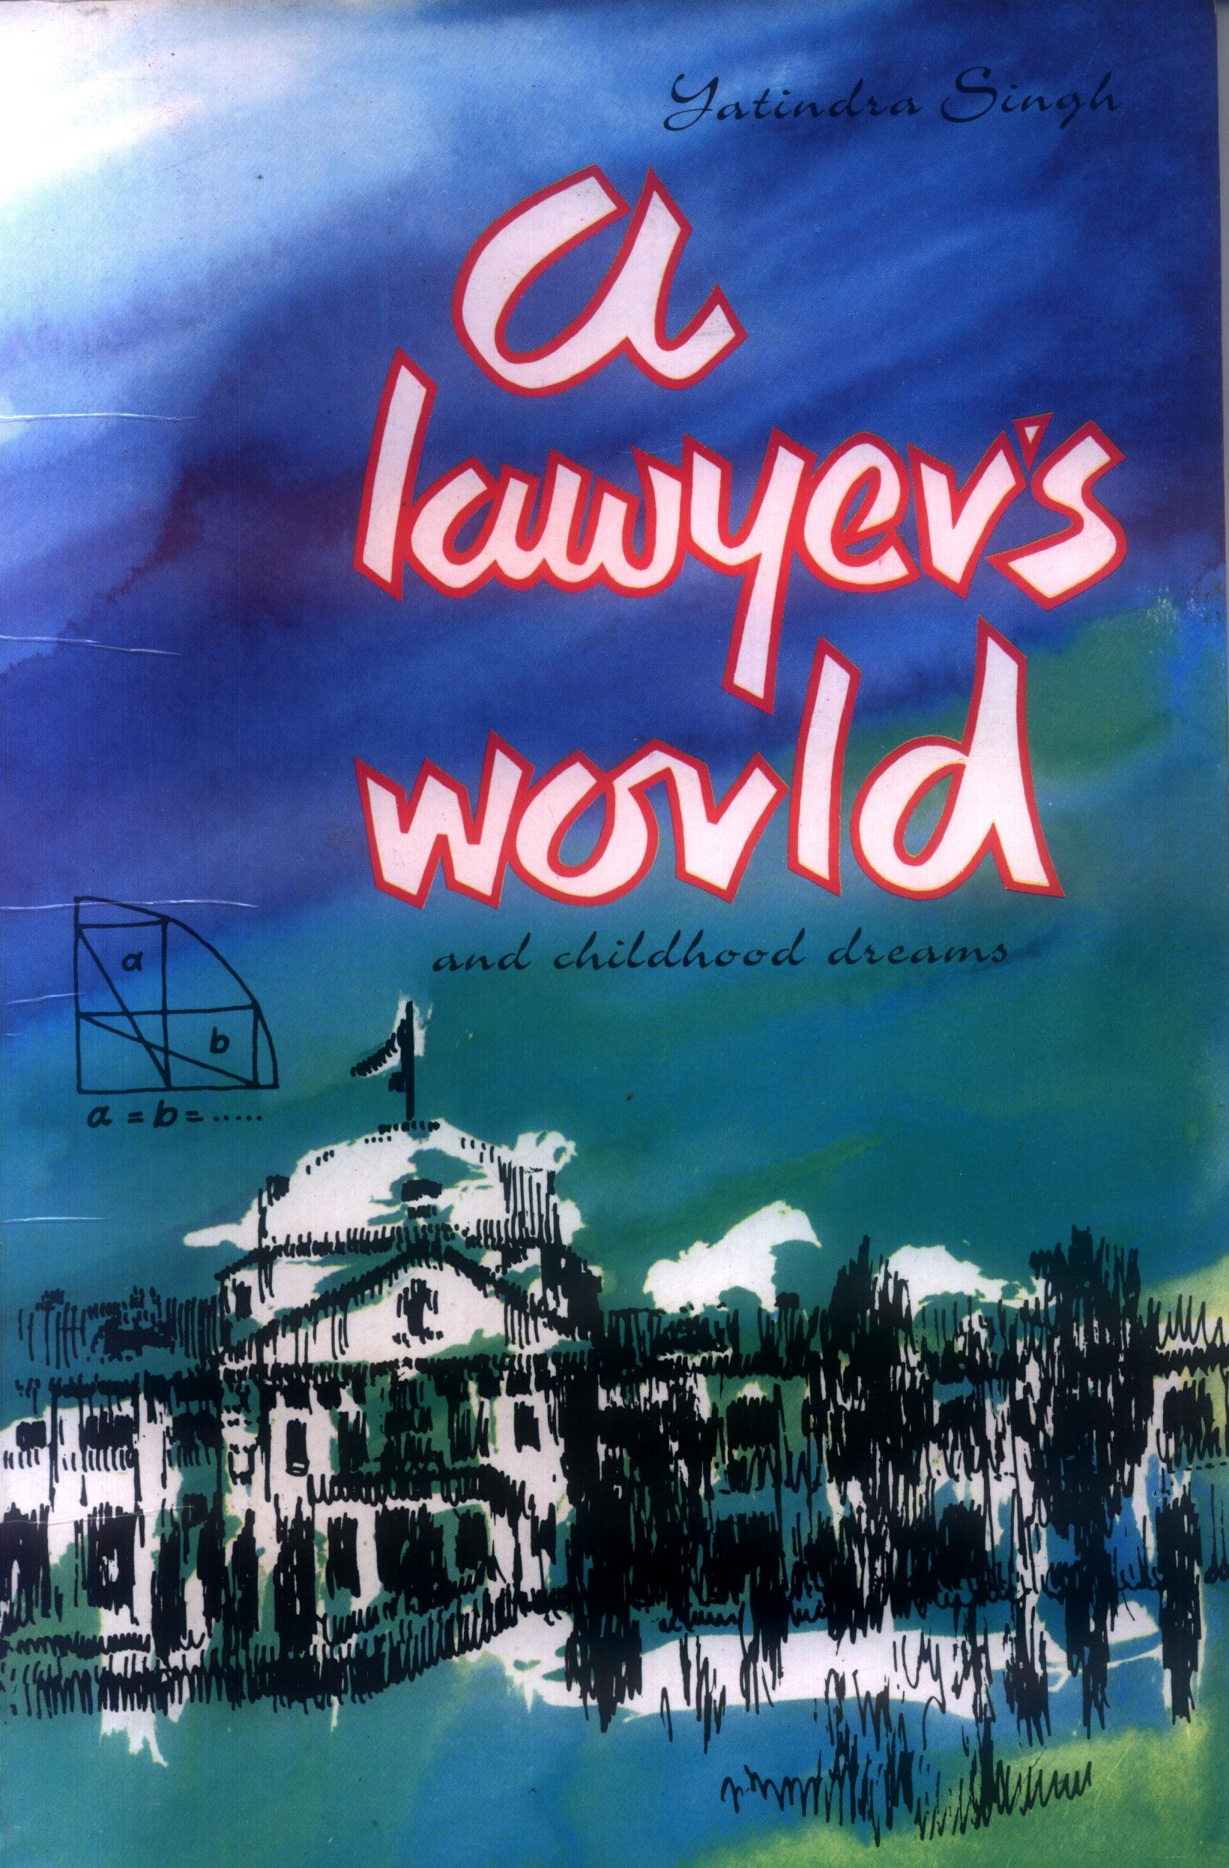
- Dr. KK Azad: I remember he used to teach us 3-D and he would say it is not 3-D but 2-D embedded in 3-D as only two coordinates are independent. He would often take us to the lawns of the quadrangle and tell us interesting anecdotes, inspire us, and often ask us a puzzles. The first time he took us to the lawns, he asked this puzzle. There are two rectangles inside The ¼^{th} of a circle has radius 0f 10 centimetres. One rectangle has length of the 8 centimetres; the other has height of 8 centimetres—prove that its hypotenuse 'a' is equal to 'b'. I liked it so much that I have put it on the cover of my first book. I leave it with you to figure out the logic.

With these fond memories, let's come back to today's topic - 'Quest for a Million Dollars'? Am I supposed to speak on Srinivas Ramanujan or on how to find a million dollars? Don't be misled by my heading; judges are not always irrelevant :-) I am going to talk about Ramanujan and this heading is relevant.

EARLY LIFE
Srinivas Ramanujan—the man who knew infinity; the man who loved numbers; a natural mathematical genius—was eldest of his siblings. He was born on 22nd December 1887 in his maternal grand father's house in village Erode, Tamil Nadu. His next two siblings (a brother and sister) died in infancy; though two other brothers survived. He spent his childhood in Kumbakonam, Tamil Nadu, where his father was a clerk in a sari shop and mother often sang in a temple in the evening.

Ramanujan's parents were childless for many years. They would often go to Namakkal, a place between Erode and Kumbakonam. There is 'Namagiri Lakshmi Narasimhaswami Temple' of Narsingh, the fourth reincarnation of Lord Vishnu. Namagiri is his consort. She was family deity of Ramanujan's family. There they would pray for a child.

It is said that Namagiri told Ramnujan's mother in her dreams that one day, she would speak through her son one day. This story was repeated many times in Ramanujan's life and had impact on him. Perhaps, it was because of this that Ramanujan used to say that Namagiri tells him the numbers, the results, the theorems and he would say,,
'An equation means nothing to me unless it expresses a thought of God.'

Ramanujan's mother used to believe in astrology. According to her, Ramanujan's stars predicted that either,
- He would be famous but his life would be too short; or
- He would live his full life like an ordinary man.
His mother thought that the first option was better for her son.

In the first three years, Ramanujan scarcely spoke but it was soon realised that he was a child prodigy. No one including his teachers understood him. One day when he was in class 3, his teacher was explaining that a number divided by itself equals one. He explained, if you distribute 3 mangoes amongst 3 persons then each will get one. Ramanujan questioned,
‘Is zero divided by zero also one. If no mangoes are distributed among any one - will still each get one?’
He was talking about the ‘Indeterminate’. Something which even today is not very well understood by students in school years.

Unlike common belief, Ramanujan stood first in the district in his primary examinations. He entered the school with reputation of being a mathematical wizard. One of his senior wanted to test him and asked him to solve the following equation for x and y
√x + y = 11
x + √y = 7
Try solving it by traditional methods and it is difficult to solve but Ramanujan gave answer before his senior could finish the question.

While in school, Ramanujan mastered Loney's trigonometry at the age of 12 and realised that trigonometric functions can be expressed by a series apart from being ratio of the sides of a right angled triangle as taught in the schools. The mathematical world had discovered this 150 years ago; he discovered it himself without knowing it. This is what happened with many theorems and results and that he discovered. He did not know that they were already discovered.

During this time, at the age of 15, he borrowed a copy of GS Carr 'A Synopsis of Elementary Results in Pure and Applied Mathematics'; it influenced his mathematical writing .

Ramanujan passed school with flying colours and received scholarship to study at Government College at Kumbakonam. However, he breathed and dreamt nothing but mathematics. He left all subjects except mathematics in the college. This led to his failure: he could not pass the college examination; he failed in all subjects except mathematics and left college to do independent work in mathematics.

Ramanujan (aged 21 years) was married to Janaki Ammal (aged 9 years) on 14 July 1909. He had to find a job to support his family.

HELP IN INDIA
Ramanujan drew attention of the mathematicians and was helped by many including Ramaswamy Aiyer, the deputy collector, who had founded the Indian Mathematical Society; he helped him to publish his work in the Journal of Indian Mathematical Society.

He was also helped by R Ramachandra Rao, the district collector of Nellore and the secretary of the Indian Mathematical Society. He sent him to Madras so that he may work at the University and helped him financially to take care of his daily needs.
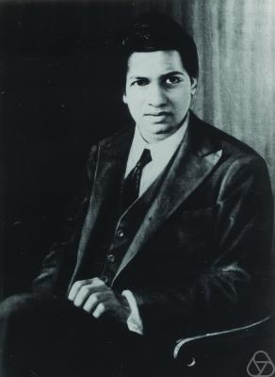Srinivas Ramanujan 22.12.1877 – 24.4.1920
In early 1912, Ramanujan got a temporary job in the Madras Accountant General's office, with a salary of ₹20 rupees per month. It lasted for only for a few weeks. In the meantime, he had also applied for a position under the Chief Accountant of the Madras Port Trust (the MPT) alongwith the recommendation from EW Middlemast, a mathematics professor at the Presidency College. Ramanujan was offered a Class III, Grade IV accounting clerk's job at ₹30 rupees per month at the MPT.

Ramchandra Rao also let the Port trust authorities know what sort of person was Ramanujan. The port trust authorities also gave every assistance to him to do mathematics and the post was made his sinecure.

Ramanujan had initially declined to go to England. There was doubt that he might lose his brahmin caste if he crossed the sea. However, it was withdrawn when his mother announced that the family goddess Namagiri had asked her not to stand in the way of her son for fulfilling his purpose of life.

There were other objections too: Ramanujan was also under confusion regarding expenses for going and staying at Cambridge; he feared that he would have to appear in the examination; and doubted if he could remain vegetarian in England (See Ramanujan's clarification in his letter dated 22.1.1914 to Hardy).

However before Ramanujan's doubts were clarified and he went to Cambridge, Gilbert Walker, the Director General of Observatories visited the port trust. He was a Cambridge trained mathematician and senior wrangler in mathematics. He saw the work of Ramanujan and opined that Hardy of Trinity College would be the best person to judge his work. He also recommended that:
'The University would be justified in enabling S Ramanujan for a few years atleast, to spend the whole of his time to mathematics, without any anxiety as to his livelihood.'

Ramanujan had already written a letter to Hardy, who went to India House in London to request them if Ramanujan could be brought to Cambridge and if something could be done for him.

India Office wrote to the Advisory Committee for Indian students at Madras about it. Their letter along with recommendation of Gilbert Walker were placed before the academic council of the Madras University, where the question was debated, whether some kind of scholarships could be given to Ramanujan for research or not.

There was some doubt if any scholarship could be given to Ramanujan as it could only be given to someone with the Master's degree. Ramanujan, at that time, did not even have a Bachelor's degree. It was only the persuasive arguments of Justice PR Sundaram Aiyar, judge of the Madras High Court and member of the Madras University syndicate that carried the day. He had submitted that the preamble of the Act establishing the University showed the prime object was to promote research. And Ramanujan had proven ability for the same.

The University recommended special scholarship of Rs. 75 per month for Ramanujan for a period of two years. The proposal was accepted by the Government on 5.4.1913. Ramanujan accepted the scholarship from 1.5.1913 as he was granted leave from this date for two years from the MPT.

In the meantime, Ramanujan, with the help of his friends, had sent letters to leading mathematicians at the Cambridge University. The first two professors, HF Baker and EW Hobson returned the papers without any comment.

Ramanujan had read a booklet titled 'Orders of Infinity' written by Godfrey Harold Hardy. In the booklet, he had found some formulae similar to his own. He also sent him a letter on 16 January 1913. This was the letter that led to most famous collaboration in history of mathematics. But before we talk about that letter and the famous collaboration between Ramanujan and Hardy, some words about British mathematicians who helped Ramanujan.

GODFREY HAROLD HARDY
Godfrey Harold Hardy was born on 7th February 1877. He died on 1st December 1947. He had a younger sister. Both did not marry. Hardy was obliged to his sister for serving him all his life.
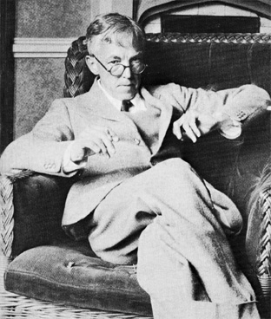GH Hardy 7.2.1877 – 1.12.1947

Hardy's parents were teachers. They were interested in mathematics. It is for this reason that Hardy became interested in mathematics from his childhood. Hardy was curious and would to go to the bottom of everything. It is for this reason that he stopped having faith in religious dogmas.

Hardy had the best of schooling in England and received his higher education from Trinity College of the Cambridge university. He was the fourth wrangler in mathematical tripos.

However, Hardy did not like the tripos system: it had fallen into the hands of coaches, who concentrated in drilling the skills of answering tricky and torturous questions in an effort to make the students do well in the mathematical tripos rather than creating an atmosphere of developing the subject.

Hardy tried to finish tripos system when he was professor in the Cambridge university. This led to reform in the system in 1909 though it is still continued as an examination.

In 1913, thirty six years old Hardy was an established mathematician. He belonged to the field of pure mathematics. He was already a Fellow of the Royal Society and was with the Cambridge University. His name appeared not only in every Mathematical Journal of that time but also in the journal of Medicine. He had propounded the Hardy-Wienberg law, which states,
‘Dominant traits would not take over and recessive traits would not die out’.

Hardy's future was secure and life was settled. It is then that he received Ramanujan's letter sometime on one morning in January 1913. It changed his life and as he would later call it,
'The one romantic incident in my life'.

The letter was written in halting English and was signed by an unknown Indian. It contained some results and theorems; some of them were known; though most of them were wild with fantastic claims without any proof. It seemed like a fraud. Hardy was used to receiving such letters making absurd claims. He threw it away into the waste paper basket.

Hardy's daily routine was to study cricket score after breakfast ; then work with his own mathematics from nine to one unless he was teaching the classes and then go for a game of tennis or walk down to the field to watch cricket .

Hardy followed the same routine but the letter haunted him. He could not put it away. He mused, could it be a work of a fraudster or a genius. In the evening he again had a look at the letter and then sent a message to his colleague John Edensor Littlewood that they would have discussion after dinner..

Well, there was another reason why Hardy had a look at the letter.

Hardy was a cricket fan. When he was in his deathbed he told his sister
'If I knew that I was going to die today, I think I should still want to hear the cricket score'.
He managed something similar. The last thing read to him was about history of Cambridge University cricket. Hardy was in College, when Ranjit Singh, the great Indian Cricketer, was in his prime. His game has something to do for removing Hardy's prejudices against a native Indian.

JOHN EDENSOR LITTLEWOOD
John Edensor Littlewood was also a well known mathematician of that time. He was the senior wrangler in 1905 mathematical tripos at the Cambridge University.

In the history of mathematics no two mathematicians have collaborated more than Hardy and Littlewood; they have produced more papers in pure mathematics together than anyone else though Hardy- Ramanujan collaboration is more talked about.

Hardy and Littlewood had discussion. By midnight they realised that the letter was from a genius. They were excited; so excited were they after receiving the letter that it was also noticed by Bertrand Russel, a leading mathematician and philosopher.

Russel was having an affair with Lady Ottoline Morrell. In one of his letter dated 2.2.1913, he wrote to her,
'… In Hall I found Hardy, and Littlewood in a state of wild excitement, because they believe they have discovered a second Newton, a Hindu Clerk in Madras on £20 a year. He wrote to Hardy telling of some results he has got, which Hardy thinks quite wonderful, especially as the man has had only an ordinary school education. Hardy has written to the Indian Office and hopes to get the man here at once. It is private at present. I am quite excited hearing of it. …'

In the letter of Ramanujan, most of the results and theorems were fantastic but one was special one. But, before we talk about it, some mathematics is necessary.

PRIME NUMERS
Natural numbers are 1, 2, 3, 4, 5, 6 ... They can be divided into two category:
- Prime numbers: The numbers higher than one and that can be divided by 1 or by themselves only. For example 2, 3, 5, 7, 11 etc. They do not have factors.
- Composite numbers: The numbers other than prime numbers. They are multiple of prime numbers like, 4, 6, 8, 9, 10 etc.

All natural numbers are either prime numbers or are obtained by multiplying prime numbers: the fundamental theorem of arithmetic states that all natural numbers (except 1) are either prime numbers or can be written as a unique product of the prime numbers except their pattern of writing.

The prime numbers are fundamental in the number system and are its building block. It is for this reason they are favourite of the mathematicians.

There are infinite number of prime numbers. Euclid was the first person to prove it by reductio ad absurdum: a method of disproving a proposition by showing that its inevitable consequence contradicts the the proposition and is absurd.

Suppose, P₁, P₂, ... P_{n} are the only prime numbers. Then there will always be a another P_{n+1} = P₁ x P_{2...}x P_{n} + 1 that is also a prime number as it can not be divided by the other prime numbers. This contradicts the proposition that P₁, P₂, ... P_{n} are the only prime numbers.

RIEMANN HYPOTHESIS
No one knows when and from where the prime numbers appear in the number system. There is no known formula that can tell us, which number would be a prime number and how to find all prime numbers.

In order to find out if a number is prime number or not, the only way is to divide it by the prime numbers before that number. This is tedious and long process of factorisation in case of very big numbers and has led to formation of private and public key in the information technology. If we could predict the prime numbers then it would end the privacy there.
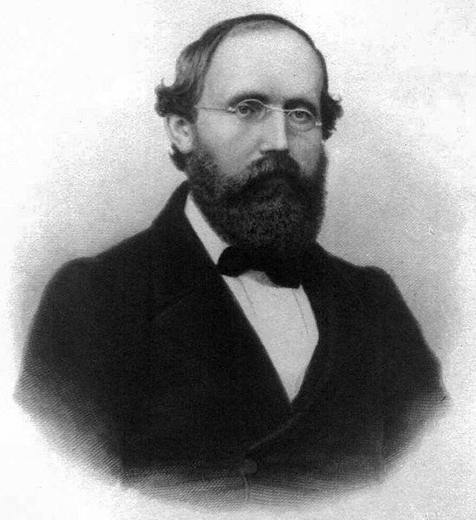Bernhand Reimann 17.9.1826-20.7.1886

Bernhard Riemann (September 17, 1826 – July 20, 1866) was a German mathematician. In 1859, he found out a way which could tell us that how many prime numbers would be there before any given number. He found a formula know as Riemann zeta function or Euler-Riemann zeta function, which is as follows,.

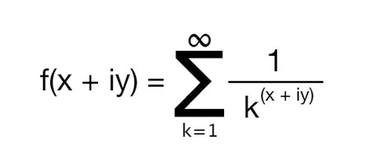
Here x, y are real numbers and i is the imaginary unit. This series converges for x>1 and it diverges to infinity for x ≤ 1.

Riemann showed that the function can be analytically continued (a technique to extend the domain of a given analytic function) to all x < 1 and its values can be calculated at any point on the complex plane (i.e. for any value of x and y).

The value of the analytically continued function is zero for negative even integers e.g. -2, -4, -6 … These are called trivial zeros and the rest are called non-trivial zeros. Riemann connected these non-trivial zeros with how many prime numbers are there less than any given number.

The non-trivial zeros of Riemann zeta function lie in a straight line and Riemann conjecture is that they will always lie in a straight line where the value of the real part of the coordinate is ½ (i.e., at a line 1/2+iy).

It is something like saying that if the two coordinates are values for latitude and longitude and Riemann Zeta Function returns the altitude for every point on a mathematical landscape then all points having zero altitude would be in a straight line. It is like saying that all points on sea level are in a straight line.

It has been checked that the ten billion non-trivial zeroes fall on the same line; it is good for the physicists but not for the mathematicians: they want to be sure that the next one and the ones thereafter will fall in the same line. For mathematicians, it is still a conjecture.

International Congress of Mathematicians
The most important international conference of mathematics is, 'International Congress of Mathematicians' (ICM); it is hosted by International Mathematical Union (IMU). It is held once in four years.

There is no Nobel prize in mathematics but the most important award in the field of mathematics is the Field's medal. It is awarded during the ICM.

In 1900, the ICM was held in Paris. In this conference, David Hilbert posed 23 problems before mathematicians and said that these were challenges for the mathematicians of the 20th century. Their solution could lift the veil of future and would help in progress of mathematics. Riemann hypothesis was 8th in these problems.

Millennium Prize Problems
Out of these 23 problems, many of them have been solved and some were still unsolved; and some new problems have arisen. Clay Mathematics Institute has announced one million dollar prize in the year 2000 for solving seven of these problems. They are also known as Millennium Prize Problems.

Riemann’s hypothesis is one of these 7 Millennium Prize Problems. Out of these 7 problems, answer to one of them has been found out: six are still unsolved and Riemann’s hypothesis is one of them. This shows how important Riemann hypothesis is. With this in background, let's talk about the letter written by Ramanujan.

RAMANUJAN'S LETTER
Ramanujan wrote his following first letter on 16.1.1913.
‘Sir,
I beg to introduce myself as a clerk in the Accounts Department.. I have no University education... I have not trodden through the conventional regular course..but I am striking out a new path myself. I have made special investigation... and the results ... are termed as startling by local mathematicians.
...
Very recently I came across a tract published by you styled 'Orders of Infinity' in page 36 of which I find a statement that no definite expression has been as yet found for the number of prime numbers less than any given number. I have found an expression which very nearly approximates to the real result, the error being negligible. I would request you to go through the enclosed papers. If you are convinced that there is anything of value I would like to have my theorems published. I have not given the actual investigations nor the expressions that I get but I have indicated the lines on which I proceed. Being inexperienced I would very highly value the advice you give me. Requesting to be excused for the trouble I give you.
I remain, Dear Sir, Yours truly,
S. Ramanujan.'

The accompanying pages contained some results that were wrong; some of that could be easily proved; some could be proved with difficulty: however, Hardy had not even dreamt about most of them. He later said,
'[Ramanujan's theorems] defeated me completely defeated me; I had never seen anything like them before. A single look at them is enough to show that they could only be written down by a mathematician of the highest class... They must be true because if they were not true, no one would have the imagination to invent them.'

Hardy replied to Ramanujan on 8 February, 1913 categorising the results into three classes:
- Already known or were easily deducible from known theorems;
- New and interesting because of their curiosity and apparent difficulty rather than because of their importance;
- New and important but require proof.
He requested Ramanujan to send proof and accounts of his work on prime numbers.

Ramanujan was encouraged by Hardy's response. He wrote his second letter to Hardy on 27.2.1913. But his methods of proof were different, he explained.
'… If I had given my methods of proof I am sure you will follow the London professor. But as a fact I did not give him any proof but some assertion as the following under my new theory. I told him sum of series 1+2+3+4... = -1/12 [for explanation see Appendix-1] under my theory. If I tell you this you will at once point out to me the lunatic asylum as my goal. I dilate this simply to convince you that you will not be able to follow my methods of proof if I indicate the lines on which I proceed in a single letter. You may ask how you can accept results based upon wrong premises. What I tell you is this. Verify the results I give and if they agree with your results, got by treading on the groove in which the present day mathematicians move, you should at least grant that there may be some truths in my fundamental basis...

I may be misunderstood if I give in a short compass the lines on which I proceed... I fear I shall not be able to explain everything in a letter. I do not mean that the methods should be buried with me. I shall have them published if my results are recognised by eminent men like you. You ask me to give you the expression I have got for the number of prime numbers within a given number. These are the expressions that I have obtained for the number of primes less than a given number...'
He then went on to explain the expression for prime number less than a given number (see Appendix-2).

Riemann died very young at the age of 39 years. His papers were burnt in a fire. There was no indication if he had proved his hypothesis; there was also no line on which to proceed to prove it.

Hardy and Littlewood thought, that in Ramanujan, they have found a person who could prove Riemann hypothesis. This was not the only reason for their excitement but perhaps was the most important reason. Hardy later decided that Ramanujan was a natural mathematical genius in the same class as Gauss and Euler.

ERIC HAROLD NEVILLE
Eric Harold Neville, a second wrangler in 1909 Maths Trips at Cambridge, was also in the Cambridge university at that time. He was coming to India to deliver some lectures in mathematics. Hardy requested him to convince Ramanujan to come to Cambridge. Eric met him and then wrote a letter dated 28 January 1914 to the Registrar of the Madras university.
'The discovery of the genius of S. Ramanujan of Madras promises to be the most interesting event of our time in the mathematical world. From the first results which he communicated, the mathematicians of Cambridge at once believed that he had uncommon ability, and the effect of personal acquaintance with the man and conversation as to his methods has been in my own case to replace that belief by certainty. At the same time the importance of securing to Ramanujan a training in the refinements of modern methods and a contact with men who know what range of ideas have been explored and what have not cannot be over estimated.
…
I see no reason to doubt that Ramanujan himself will respond fully to the stimulus which contact with Western mathematicians of the highest class will afford him. In that case his name will become one of the greatest in the history of mathematics, and the University and City of Madras will be proud to have assisted in his passage from obscurity to fame. '

TO CAMBRIDGE
The finance for Ramanujan to go to Cambridge was given by the Madras University with special sanction by the Government {Document no. 182 of Government of Madras Education Department 12.2.1914 (see Endnote-1). He boarded the ship to London on 17 March 1914, and arrived in London on 14 April.

Hardy had already received 120 theorems from Ramanujan in the first two letters, but there were many more results and theorems to be found in his notebooks. Hardy saw that some were wrong, others had already been discovered, while most of them were new breakthroughs.

Ramanujan was awarded a BSc degree through research (later renamed PhD) on 16 March 1916 for his work on highly composite numbers. On 6 December 1917, Ramanujan was elected to the London Mathematical Society. He became a Fellow of the Royal Society in 1918, becoming the second Indian to do so, and he was one of the youngest Fellows in the history of the Royal Society. On 13 October 1918, he became the first Indian to be elected a Fellow of Trinity College, Cambridge.

RAMANUJAN AND HARDY
Ramanujan and Hardy were exact opposites: Ramanujan a theist, his faith in God was so firm that an equation for him had no meaning unless it was expression of a thought of God, Hardy, an atheist, thought mathematics proved otherwise; Ramanujan did not have a good schooling and no education after it, Hardy got the best of education—public school and then Cambridge University; Ramanujan was intuition incarnate, Hardy was the apostle of proof; Ramanujan was original and intuitive, he could feel the results, Hardy believed in logic, for him nothing was true unless proved. The only thing common between the two was Mathematics: it was their religion.
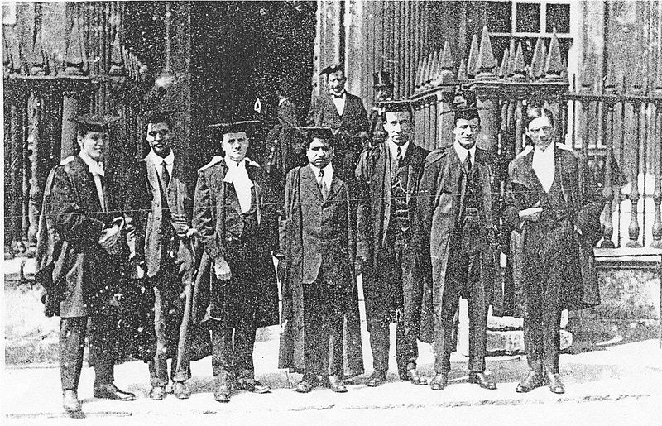Ramanujan in centre at Cambridge University
May be, Hardy and Ramanujan complemented each other. It is for this reason that they got off well. And Hardy, even after Ramanujan's death at a very young age, went on to write papers on the mathematics of Ramanujan (for their work on partitions of numbers see Appendix-3).

It is often said what would have happened if Ramanujan, instead of learning mathematics himself would have learnt it traditionally. Hardy answered it in 1927.
‘He would have been a greater mathematician... discovered more that was new... (But) he would have been less of a Ramanujan and more of a European Professor and the loss might have been greater than the gain.’

Hardy was once asked, what was his greatest discovery. ‘Ramanujan’ he firmly answered. At another time he said,
‘I did not invent him. Like other great men, he invented himself.’

At the end of his life when Hardy would give an explanation for irrelevance of pure mathematicians to a common man's need in ‘A mathematician's apology’, (See Appendix-4 book-5) a classic and still remembered for its mesmerising hold on readers, he would console himself,
‘I have done one thing... (that pompous people) have never done... (It) is to have collaborated with... Ramanujan on something like equal terms.’

TAXI NUMBER
No article about Ramanujan can be complete without the incident regarding Taxi number. Ramanujan was ill and admitted in a hospital in London. Hardy would visit him there on weekends. On one of his visits Hardy noticed the Taxi number 1729. On reaching the Hospital he mused that if it was a dull number and being a multiple of thirteen (13x133) may be bad omen. Pat came the reply from Ramanujan.
‘No, it is a very interesting number. It is the smallest number, which can be expressed as the sum of two cubes in two different ways. 1729 is equal to 12³ +1³ and 10³+9³.’

RAMANUJAN'S DEATH
Ramanujan's health was never good. In England, he was alone and away from his home; there was the scarcity of vegetarian food; the climate was much colder than he could bear; and his involvement with mathematics: they all contributed and his health worsened.

Ramanujan returned to India in 1919 and died soon thereafter on 24.4.1920 at the young of 32.

The cause of Ramanujan's death has not been determined though Tuberculosis is the favoured diagnosis, but a vitamin deficiency may have been an important factor. In 1994, Dr. DAB Young after examining the medical records and symptoms of Ramanujan concluded that he died of hepatic amoebiasis, a parasitic infection of the liver widespread in Madras.

The Cambridge gossip was that Ramanujan cooked his own Indian food in his College rooms in special copper vessels, which became corroded for being improperly washed; and the corrosion eventually poisoned him. (see letter of GC Mcvittie to Bruce Berndt dated 6.8.1987 at page 307 of Ramanujan: Letters and Commentary)

His widow, S. Janaki Ammal, lived in Chennai until her death in 1994.

CONCLUSION
In 'A Mathematician's Apology', Hardy says,
Archimedes will be remembered when Aeschylus is forgotten, because languages die and mathematical ideas do not. 'Immortality' may be a silly word, but probably a mathematician has the best chance of whatever it may mean.'
Hardy was right: Ramanujan has achieved immortality through mathematics.

It is good that Government of India is celebrating this year as year of mathematics. Perhaps, by talking about Ramanujan and generating interest about him, may produce another Ramanujan. Riemann's conjuncture still unproven; one million dollars are still waiting for another Ramanujan.

Yatindra Singh, Judge, Allahabad High Court, Allahabad
Email: ysingh@allahabadhighcourt.in

Endnote-1: The government document dated 12.2.1914 sanctioning scholarship to Ramanujan to go to Cambridge spells his name as Ramanujam. The Commentary at page 101-102 of the book 'Ramanujan Letters and commentary' explains it as follows:
'Ramanujan and Ramanujam are two transliterations of the same Sanskrit name RAMANUJAHA, which means younger brother of Rama. In Ramanujan's native language Tamil, there are also two distinct spellings. At the Town High School and at the Government College in Kumbakonam, rooms are named in honour of their most illustrious student, and, in each case, the spelling Ramanujam is used.'

There are two notes of W Francis and Horne, both ICS (appointed in 1888 and 1880) with this document and are as fallows:

'This Ramanujam is a budding Newton on whose account rules and precedents may well be stretched. The praise given here to his work by Mr. Neville ( a Fellow of Trinity , Cambridge, who has come out specially to give lectures in higher mathematics) could scarcely be higher. - W. Francis

It is a very remarkable proposal. I suppose it is strictly irregular, but if Mr. Neville is to be believed, some irregularity would be justified. - WO Horne.'

Endnote-2: Endnote-3: After the talk, Prof Ashok Gupta retired Dean of the science faculty, Allahabad University informed me that:
- Prof T Pati had proved Riemann's hypothesis to be wrong in a paper published at (http://lanl.arxiv.org/abs/math/0703367);
- Though, the mathematicians do not accept it to be correct without pointing out any mistake in the same.
Personally, I think that as the Riemann's hypothesis has neither been proved nor disproved for such a long time and no contrary example has been found, it may be one that as Godel says, can neither be proved nor disproved in this number system.

Endnote-3: All pictures except the first one are from Wikipedia

Appendix-1
CLT Griffith was professor of civil engineering at Madras college of Engineering. He was student of MJM Hill Professor of Mathematics at University College at London. Griffith sent some papers of Ramanujan to Hill, who offered some serious advise to Ramanujan but apparently could not understand his notations and wrote on 3.12.1912,
'Mr Ramanujan has fallen into the pitfalls of the very difficult subject of Divergent series.
Otherwise he could not have got the erroneous results you send me
1+2+3+4+....+ ∞= -1/12
1²+2²+3²+....+ ∞²= 0
1³+2³+3³+....+ ∞³= 1/240 (There appears to be some mistake - see below)
All 3 series have infinity for their sum...'

The first and third result was also sent by Ramanujan to Hardy in his first letter and the first one was again mentioned in the second letter to Hardy. It appears that the reference to the London Professor was to MJM Hill. Hardy and Littlewood were also perplexed till they understood Ramanujan's connotations. They are results of Riemannian calculation for the Zeta function fed with –1, –2, and –3.

In the book 'The Indian Clerk', Hardy explains it as follows:
'”...Well, at least I've worked out what he's up to with the damn 1 + 2 + 3 + 4+... = -1/12.”
"What?”
"I'II show you.” With a quick sweep of the cloth, hardy wipes his blackboard clean. “Essentially, it's a matter of notation. His is very peculiar, Let's say you decide you want to write ½ as 2⁻¹ . Perfectly valid, if a little obscurest. Well, what he's doing here is writing 1/2⁻¹ as 1/1/2, or 2. And then, along the same lines, he writes the sequence 1 + 1/2⁻¹ + 1/3⁻¹ + 1/4⁻¹ + …......as 1/1/1 + 1/1/2 + 1/1/3 + 1/1/4 + …......, which is of course 1 + 2 + 3 + 4 + ….so what he's really saying is 1 + 1/2⁻¹ + 1/3⁻¹ + 1/4⁻¹ + …...= - 1/12”.
“Which is the Riemannian calculation for the Zeta function fed with – 1.”
Hardy nods. “Only I don't think he even knows it's the zeta function. I think he came up with it on his own.”
"But that's astounding. I wonder how he'll feel once he finds out Riemann did it first.”
"My hunch is that he's never heard of Riemann. Out in India, how could he? They are behind England, and look how far England is behind Germany. And of course, since he's self taught, it makes sense that his notation would be a little―well―off.
"True, except that he seems to know it's off. Otherwise why put in the bit about the lunatic asylum?'
"He's toying with us. He thinks he's great.”
"Most great men do.”'
Appendix-2
The prime number theorem can be broadly stated as,
'Number of primes less than number x or pi of x or π(x) ~ x/log x.'
This approximation improves as x becomes larger.

Riemann had made six conjectures regarding Riemann-Zeta function. Five of them were proved by the time Ramanujan came around. The sixth one, that non-trivial zeros in Riemann-Zeta function lie in a straight line, where the value of the real part of the coordinate is ½, is known as Riemann hypothesis. If this hypothesis is true then Riemann was able to point out other conclusions regarding distribution of prime numbers that go beyond the prime number theorem.

One can say π(x) = x/log x + ε, where ε is different for different x. In case Riemann's hypothesis is true then it promises to to give exact figure of ε.

Ramanujan has come up with his own version of Riemann-Zeta function and numbers of primes based on the same. This gave correct numbers of primes for smaller values: this had misled Ramanujan in believing he had found an expression that gave correct number of primes, less than any number. However, it was not correct; it did not give correct numbers of primes for very large numbers though it gave better estimation than prime number theorem.

When Ramanujan reached England, Hardy explained to him that he (Ramanujan) had ignored non-trivial zeros in Riemann-Zeta function leading to wrong assertion. Littlewood later said,
'These problems tax the last resources of analysis … Ramanujan could not possibly have achieved complete success. What he did was to perceive that an attack on the problem could at least begun on the formal side. And to reach a point at which the main results were plausible. The formulae do not in the least lie on the surface, and his achievement, taken as a whole, is most extraordinary'
Appendix-3
A number can be written as sum of other numbers. For example 4 can be written as 4 or 3+1 or 2+2 or 2+1+1 or 1+1+1+1. These (leaving aside there rearrangement ) are know as partitions of a number. 3 can be written in 3 ways or p(3)=3. Similarly, p(4 ) = 5, p(7) = 15, P(10) = 42, p(50) = 204226, p(100)= 190,569,292

They increase dramatically as number increases.

Ramnujan and Hardy together came out of with the following formula in 1918 to calculate number of partitions.
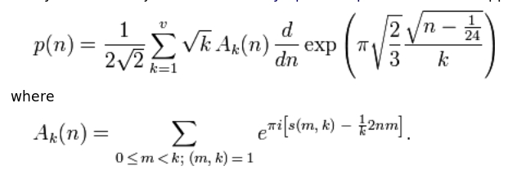

Ramanujan and Hardy checked this formula for p(200). It gives value 3,972,999,029,388.004. They also got it checked manually, which took a month. It gives correct answer if the decimal is removed..

Cambridge mathematician Bela Bollobas says,
'I believe Hardy was not the only mathematician who could do it … there were others who could have played Hardy's role. But Ramanujan 's role in that particular partnership I don't think could have been played at that time by anyone else.'
Appendix-4
(If you wish to know more about Srinivas Ramanujan then it will be instructive to read the following books, articles and see BBC documentary.)
1-Ramanujan letters and commentary by Bruce C Berndt and Robert A Ramkin. (History of Mathematics volume-9 published by American Mathematical Society.)
The book contains letters written by Ramanujan as well as letters related to Ramanujan. It also contains brief biography sketches about Ramanujan as well as people involved in his life.

2-The Man Who Knew Infinity : A Life of the Genius Ramanujan by Robert Kanigel
This book is very inspiring book. It is the story of Ramanujan. It is the story of Hardy as well; and what they meant to each other. It is gripping and well written. It is one of the finest biographies ever written.

It is the story of a poor but self-confident young man. It is a story of scientific achievement in adversity. It not only talks about the achievements but also narrates the psychology and cultural differences of that time.

The book deals with the mathematics that Ramanujan did; the equation that he loved. They are explained in a simple way. Even if you do not understand them you can skip them. This does not affect the rhythm of the book.

The book undoubtedly will inspire young readers to emulate the great man and who knows might produce another Ramanujan.

Robert Kanigel is also making a film on this book.

3-The Indian Clerk by David Leavitt.
In 1936, Harvard university was celebrating its 300th anniversary. On this occasion many seminars, conferences on art and science were organised. Hardy had given some lectures in this conference on Ramanujan. The novel 'The Indian Clerk' starts at that time but is about the time when Hardy received Ramanujan's letter and Ramanujam went back to India.

The book is a kind of historical fictional novel. The main character and the incidents are correct but timings of some of them are changed and some fictional incidents have been added. But the book is written in such an interesting way that it is difficult to leave.

The novel talks about some lectures that Hardy in fact gave and some lectures, which he did not give but he thought of them at that time.

It is true that Eric Harold Neville had come to India in 1913. Hardy had asked him to meet Ramanujan and request him to come to Cambridge university. His wife Alice Neville was bothered about Ramanujan and used to look after him but was not romantically inclined towards him.

Littlewood had a love affair with a married woman but this was not at the time when Ramanujan was there. It was much after Ramanujan left India.

4-Srinivas Ramanujan by Prof. EH Neville 1942 (Volume 149 ) Nature 292
It is written by Neville, who had convinced Ramanujan to go to Cambridge.

5- A Mathematician's Apology by GH Hardy
A classic and still remembered for its mesmerising hold on readers; written in 1940, it has some personal contents; deals with beauty of mathematics; and gives an insight into the mind of a working pure mathematician to the layman . Canto has published it with a foreword by CP Snow. It provides an insight into Hardy's life and collaboration between Hardy and Ramanujan.

6- Letter of an Indian Clerk
BBC documentary on Ramanujan made in the birth centenary year 1987. It can be seen at Youtube at
http://www.youtube.com/watch?v=OARGZ1xXCxs

Appendix-5
(Some good general books about the Riemann Hypothesis are as follows. The third book is more technical than the first two.)
- The Music of the Primes:Searching to Solve the Greatest Mystery in Mathematics by Marcus du Sautoy
- The Riemann Hypothesis: The Greatest Unsolved Problem in Mathematics by Karl Sabbagh
- Prime Obsession: Berhhard Riemann and the Greatest Unsolved Problem in Mathematics by John Derbyshire

If you wish to know more about the Bourbaki then don't forget to read 'The artist and the mathematician: the story of Nicolas Bourbaki, the genius mathematician who never existed' by Amir D. Aczel.
This is sum of Reimann- Zeta function for −3 and it is 1/120 and not 1/240 as mentioned. However, I have mentioned it as has been mentioned in the letter of Professor Hill and the commentary accompanying the same in the book 'Ramanujan: Letters and Commentary'. Nevertheless, this result is also mentioned in the first letter to Hardy where its result is correctly printed in the same book as 1/120.

