PREJUDICE—WOMB OF INJUSTICE
(Summary: The article talks about the novel 'To Kill a Mockingbird' on the 50th year of its publication, the Scottsboro Boys' Case that inspired it, Samuel Leibowitz the leading lawyer in the case, and his biography 'Courtroom'.
This talk was delivered by Justice Yatindra Singh in the Faculty of Law, University of Allahabad on 21.8.2010.)

Last year Justice Markandey Katju, Judge, Supreme Court of India, inaugurated the first All India Tax Moot Court competition at Allahabad University. He advised the students to emulate:
- Clarence Darrow, the most celebrated American trial court lawyer between the end of 19th century and beginning of the 20th century and reminded them of his book 'Attorney for the Damned'; and
- Atticus Finch, the fictional lawyer character in Harper Lee's novel, 'To kill A Mockingbird'—an American classic of the 20th century.
After the talk, some of the students, asked me about them. This is the 50th year of publication of the novel 'To Kill a Mockingbird', so here is the story of Atticus Finch. The story of Clarance Darrow will be narrated at some other time.

TO KILL A MOCKINGBIRD—ATTICUS FINCH
The novel 'To Kill a Mockingbird' was published in 1960. It has been translated into 40 languages and has sold more than three crores copies. It has never been out of print, since its publication. Lee herself never expected such a reception. She later said,
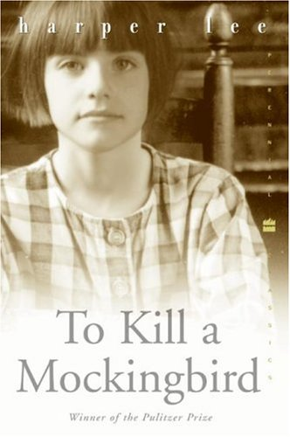
'I never expected any sort of success with 'To Kill a Mockingbird'. I was hoping for a quick and merciful death at the hands of the reviewers but, at the same time, I sort of hoped someone would like it enough to give me encouragement. Public encouragement. I hoped for a little, as I said, but I got rather a whole lot, and in some ways this was just about as frightening as the quick merciful death I'd expected.'

Lee never wrote any other book. She vanished from the literary world. She explained.
'When you're at the top, there's only one way to go.'

'To Kill a Mockingbird' is a story of a six year old young girl: Scout, her elder brother Jem, and their friend Dill―set at the time of great depression around Maycomb Alabama. Scout is the narrator of the story and Atticus Finch is her father: a middle aged widowed lawyer. Their neighbour is a mysterious man known as Boo Radley―a few in town had seen him. The kids have their imagination running wild about him and the reasons for his remaining hidden.

The story revolves around their adventures and ultimately the trial of Thomas (Tom) Robinson, a Black who was tried for committing rape on a white girl. He did not have a lawyer and the Judge appointed Atticus Finch, as a friend of the court, for him. Most of the town's residents do not approve of his accepting the defence brief but Atticus not only accepts it but tries his best to save the accused. He never wanted his children to attend the trial fearing reprisal against them but the children secretly do attend it.

Atticus proves that the accused is innocent and the victim was beaten by her father, yet because of the colour, because of the prejudice, the accused is convicted. Later, while trying to escape, he is killed.

The father of the victim becomes angry with Atticus and tries to kill Scout and Jem. It is at this juncture that the mysterious Boo Radley saves their lives.

The novel is a cultural touchstone and shows how prejudice affects the mind. It has many gems and portrays the philosophy of life in its own way.

Here is the advice that Atticus gives Scout. It is the best that I liked in the novel,
'Scout, if you can learn a simple trick, you'll get on better with all kinds of folks. You never really understand a person until you consider things from his point of view … Until you climb into his skin and walk around in it.'
…
Most people are … nice … when you finally see them.

Scout questions her father why is he defending the Black. He tells her,
'For number of reasons. The main one is, if I didn't, I couldn't hold up my head. I couldn't represent this country in the legislature
…
You might hear some ugly talk about it at school, but do one thing for me: no matter what anybody says to you, you just hold your head high and keep those fists down.'

This reminds me of Operation Bluestar. Sikh sepoys of the Sikh Regiment Centre, Ramgarh, had looted arms and ammunition, killed their commanding officer, and started for Amritsar. They were apprehended and JCOs and NCOs were tried by court martial at Allahabad. No advocate was willing to accept their briefs. I remember the criticism and contempt that I faced from all sides for taking up their defence briefs. Only my father supported me. He knew prejudices well: he was a MISA detnue during emergency.

The victim was hit on the right side of her face. During cross-examination, it had come in evidence that she was hit face to face. The left hand of the accused was useless: it was torn apart by a cotton gin when he was a boy. During cross examination of the father of the victim, Atticus asks him to sign. It surprises many: a good lawyer knows what to ask in the cross examination. Scout also mentally observes,
'Atticus seemed to know what he was doing―but it seemed to me that he'd gone frog-sticking without a light. Never, never on cross-examination ask a witness a question you don't know the answer to was a tenet I had absorbed with may baby food.'

The father of the victim signs with his left hand. It shows he was a left hander. It is almost impossible to hit a person face to face with right hand on the right side of the face but easy to hit by the left hand. Atticus wanted to show that it was the father of the victim who had hit her and not the accused.

The novel also explains why it was titled 'To Kill a Mockingbird'. Atticus presents an air gun to his children for Christmas and says,
'I'd rather you shoot at tin cans in the back garden but I know you'll go after birds. Shoot all blue jays you want, if you can hit them, but remember it's a sin to kill a mocking bird'.
Their neighbour explains,
'Your father is right. Mockingbird don't do one thing but make music for us … they don't do one thing but sing their hearts out for us. That's why it's a sin to kill a mockingbird'.

The novel is about loss of innocence and mockingbird is symbolic; it is about civil rights movement as well. But it goes beyond that―it is about right and wrong; it is about kindness and meanness.

In 1962, a film adaptation of the novel by the same name was also made. It had Gregory Peck as Atticus Finch and Mary Badham as Scout. It won three Oscars including the best actors award for Peck. It also won an award in the 1963 Cannes film festival. Many say, the film gave an opportunity for Peck to play himself.
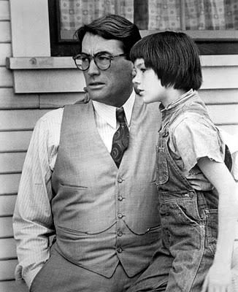Atticus (Gregory Peck) and Scout (Mary Badham) in a scene from the movie

In real life, Lee had an elder brother and a friend. Their father was an advocate and before marriage her mother's name was Finch. Many say, it is Lee's Autobiography. She negates it but accepted that whatever she saw in her life, was woven into the novel. But what was that inspired her to write the novel?

COURTROOM: SAMUEL LEIBOWITZ
What Clarance Darrow was in the first quarter, Samuel Leibowitz was in the second quarter of the 20th century. He was born on 14th August 1893 in Romania. His father migrated to US in 1897. At that time, their family name was Lebeau but after migration, their friends advised them to Americanise it and Lebeau became Leibowitz.

Leibowitz in his student life enjoyed debates and elocution (see Endnote-1). He took up law on his father's advice and completed his law education from Cornell University. By the end of first quarter of the 20th century, he became a leading criminal trial lawyer in US. Later, he became a Judge and died on 11th February 1978.
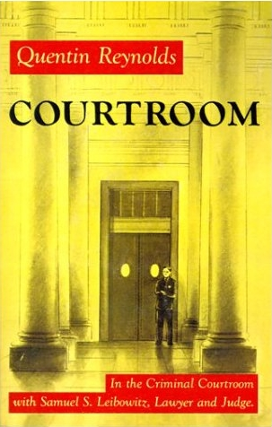
Leibowitz's biography has been romanticised by Quentin Reynolds in the book 'Courtroom'. I was reluctant to become a lawyer; his biography not only had an impact on me but also encouraged me to become a lawyer. It should be read by everyone, who aspires to be a lawyer. It is interesting to note as to how Leibowitz got his first case and what happened in that.

The First Case
Leibowitz began his practice as a brief less lawyer. This is exactly how most of us begin our careers. The court generally appoint a new entrant as a friend of the court for the accused who are not able to afford services of a lawyer. It not only encourages them but they have the time too. This is how Leibowitz got his first case.

The accused in that case was charged for breaking open a saloon and stealing, money and liquor. The next day he was found drunk, in the drain, and with a key in his pocket by which he was suspected to have opened the lock of the saloon. He also confessed to the crime before the police. Unlike our country, where confessions before the police cannot be proved under sections 25 and 26 of the Evidence Act, in the US such confessions are admissible.

Leibowitz's colleagues advised him to confess the guilt of his client and opt for plea bargaining. He was in two minds:
- Should he admit the guilt of his client then the case would not be contested. In that event, he might not become famous; and
- If he did not then his client was likely to land up in the jail for longer period.

Leibowitz pondered over the case for many nights. This is how good lawyers work. They are not like the fictional character Perry Mason, who used to think as the case went on. In real life, good lawyers ponder, re-ponder, and then ponder again over the weak as well as strong points of their case. This was what Leibowitz did and then he gambled: it was like a punch in the dark; it might just hit the bull's eye.

When the case started, Leibowitz did not plead guilty. After the prosecution finished its case, the accused took the witness stand and deposed that he confessed to the crime because of the police torture. Then, Leibowitz asked, whether the District Attorney (the prosecuting counsel) (DA) had himself seen that the key found in the accused pocket opened the locks of the saloon or not. If he had not, then he invited the Judge and the Jury to come along with him to see for themselves if the key opened the locks of the saloon or not. If it could not then he submitted that his client could not be held guilty.

The DA had not personally seen whether the key opened the lock or not. He debated about the risk involved. If the key did not open the lock then it would be very insulting. If it did, even then, at the most the accused would be convicted. There were thousands of such petty cases pending in the court and they had to be decided: was it worth spending the time? Considering the risk involved and the time factor, the DA chose to rest the case; so did the defence: and the jury did not take any time to acquit the accused.

After the case was over, Leibowitz tried to open the locks of the courtrooms with that key. It opened all the locks: it was a kind of master key.

The newspaper did not talk about the case but in the jail, prisoners talked about it; in the court, the lawyers talked about it. And from here, his fame started rising: the key opened the door of his success.

People Vs. Peter Brown
The book 'Courtroom' talks about many interesting cases and one such case was of People vs. Peter Brown. This case is neither memorable for any legal principle, nor for the personalities involved but for a long, ugly scar on the body of Rita Antonina that no one thought to be of any consequence. It shows how a minute detail can turn a case.

Peter Brown was a police officer. He was being prosecuted for taking undue advantage of Rita Antonina. Both had different stories about the incident.

According to Peter Brown,
- He was investigating houses for prostitution. One afternoon he was passing by a street. Rita Antonina smiled at him from the window and beckoned him to come up. He went up but made an appointment for the next day.
- The next day, he went up at the fixed time and paid her a marked note. She took the money, dropped her dress, and was fully naked. It is at this stage Brown revealed his identity. He asked her to dress up and go with him to the police station. He went to the window and signalled his colleagues to come in.
- Rita Antonina dressed up, tore the note to pieces, and flushed it down the drain.

According to Rita Antonina,
- She was a happily married housewife;
- She never undressed as was the case, according to Brown;
- Brown tried to take undue advantage of her.
It was Brown's words against Rita Antonina's and she was beautiful.

Peter Brown was indicted (committed) for trial. The press believed Rita Antonina so did the jury. They had already decided the case before it began. It is easy to believe police brutality.

It was at this stage, Leibowitz was engaged to defend the cop. He believed him. This is how the book records conversation between the two regarding the scar.
"I can't imagine anyone wanting to have an affair with that woman," Brown said miserably. "Honest, Mr. Leibowitz, that scar alone would be enough to scare anyone off."
"Scar?" Leibowitz looked puzzled. "There was a picture of her in the News this morning. I didn't notice any scar on her face."
"Not on her face," Brown said casually. "On her belly, like an appendicitis scar but it must be seven inches long. I never saw such a scar."
"When did you see this scar. Leibowitz asked impatiently.
Brown was surprised at the urgency in his lawyer's voice. "I couldn't miss seeing it," he said. "I told you she lay there on the bed without a stitch on.
"Why didn't you mention this in the Magistrate's court when you testified against her?" Leibowitz demanded.
"Nobody asked me to describe her.” the cop said puzzled at the interest the lawyer was manifesting. " Why, Mr Leibowitz, what's so important about the scar?” “Nothing ....nothing,” Leibowitz said sarcastically.

After the prosecution led their evidence, Brown went up in the stand and told his story. He deposed that the lady had undressed and was completely naked. Leibowitz didn't ask him any question about the scar. Wallace was the brilliant DA for the prosecution. At the end of his cross examination he asked (this is again from the book),
"You testified that Rita Antonina lay there on the bed naked," Wallace [prosecuting counsel] boomed. "Now, Brown, is there anything about her that stands out in your memory?"
Brown paused a moment and then said thoughtfully, "Now that you mention it, Mr. Wallace, there is. She had a long, ugly scar on her belly that ran all the way from her navel right down to her ... well ... her groin. I could never forget that scar as long as I live."
...
"Why didn't you mention this scar before?" Wallace thundered.
"No one ever asked me about it," Brown answered with complete truthfulness, and then Wallace dropped him. Leibowitz recalled the complaining witness [Rita Antonina] to the stand to ask her just one question.
"Do you have such a scar as the defendant described?" he asked gently.
Her eyes searched the floor, and for a moment she hesitated. The crowded courtroom was tense with expectancy.
Then she choked out a mumbled, “Yes, I do.”

It belied her case that she never took off her clothes. The jury did not take any time to acquit Brown.

Scottsboro Boys' Case
In later life, Leibowitz would often go on vacation but wherever he went, he would visit the court. He preferred courtrooms to the monuments. Once he visited Miami courthouse. In the case there, there wasn't anything to interest him except for the jury box: there was a black man in the jury. During lunch time, Leibowitz asked the lawyer about it. The lawyer answered (from the book),
'Yes, it is something new. This is the first time in our state we have had a nigger on a jury and it's all on account of a son-of-a-bitch named Samuel Leibowitz from New York. He came down to Alabama a few years ago to try a case and somehow he got to the Supreme Court in Washington, and damned if we haven't had to put niggers on our juries over since.'
This was due to Scottsboro Boys' case.

Leibowitz fame reached its peak with the Scottsboro Boys' case: the case that influenced Harper Lee in writing the novel. She was from Alabama and this trial also took place in Alabama.

Scottsboro Boys' case is not only the most talked about US constitutional case of the 20th century but is also a milestone in the area of civil rights. It had gone to US Supreme Court twice and both times, the death penalty was set aside and the case was sent back for re-hearing. Perhaps, it happened only in this case in the history of the US Supreme Court. Here are the facts of that case,

1930s was a time of depression in the US. Hobos often went places from one place to other on freight trains in search of jobs. On March 25, 1931, nine Blacks (aged from 12 to nineteen) were pulled off from a freight train in Alabama and were initially arrested for assaulting white boys on the train. There were then for two young white women Ms. Victoria Price and Ms. Ruby Bates on the train too. They were later charged allegedly for raping them in a gondola of the same train.

On the request of the State, they were tried in three groups in Scottsboro (this is why it is known as Scottsboro Boys' case). Between April 7-9,1931, eight of the Scottsboro Boys were sentenced to death. The trial of the ninth one Roy Wright (the youngest 12 or 13 years old) ended in a mistrial when some jurors held out for a death sentence even though the prosecution asked for life imprisonment.
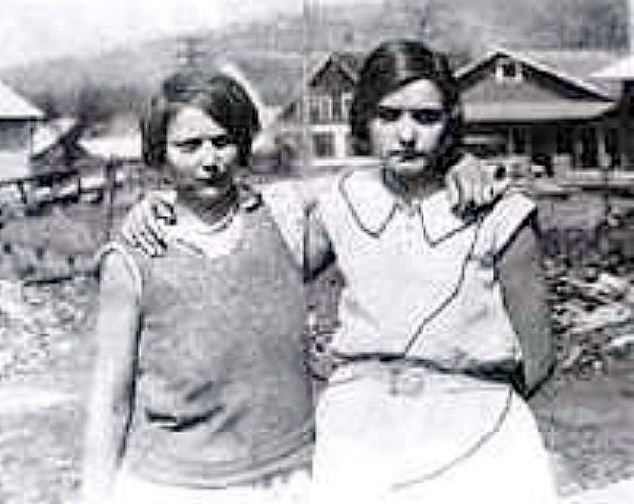Ruby Bates and Victoria Price
Their executions are stayed pending appeals before Alabama Supreme Court. In between the hearing before the Supreme Court a new development takes place. On January 5, 1932, in a letter Ruby Bates,denies that she was raped. However in March, 1932, the Alabama Supreme Court by a vote of 6-1, affirms the convictions of seven of the boys over the strong dissent by Chief Justice John Arderson that the accused were accorded a fair trial (242 Ala. 524). The conviction of one of them, Eugene Williams aged 13 years was reversed on the grounds that he was a juvenile under state law. The news of their convictions spread and the plight of the Scottsboro Boys became a 'cause celebre'.

The appeal was taken to the US Supreme Court and it was argued that the accused were denied due process and equal protection of law in contravention of fourteenth amendment as they were,
- Not given a fair, impartial, and deliberate trial,
- Denied the right to counsel and opportunity to prepare for the trial;
- Tried before jury from which qualified members of their own race were systematically excluded.
The appeal was allowed by the US Supreme Court by 7-2 on the second ground (see Endnote-3). Their conviction was set aside: the case was sent back. The US Supreme Court in Powell Vs. Alabama 287 US 45 held,
'A defendant should be afforded a fair opportunity to secure counsel of his own choice. Not only was that not done here, but such designation of counsel as was attempted was either so indefinite or so close upon the trial as to amount to a denial of effective and substantial aid in that regard.
…
The failure of the trial court to give them reasonable time and opportunity to secure a counsel was clear denial of due process.'

After the case was remanded by the US Supreme Court, it was transferred to Decatur. International Labour Defence (ILD), the law wing of the communist party of the US, had taken control of the defence. It requested Samuel Leibowitz to defend the accused. Leibowitz accepted the brief but put his conditions,
'While, as you are quite aware, your organization and I are not in agreement in our political and economic views, your letter arouses my sympathetic interest, because it touches no controversial theory of economy of government, but the basic rights of man.
Let me say at the outset that if I serve this cause, as you suggest I should, I will not serve it for money; nor will I permit you to repay the expense I may incur'.
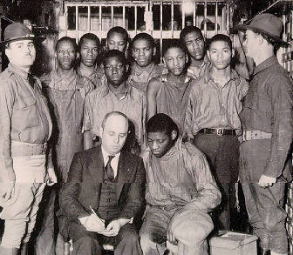Samuel Leibowitz with the Scottsboro Boys
Patterson, one of the nine accused, was tried first. This time Ms. Ruby Bates appeared on behalf of defence. She deposed that:
- The Blacks had not teased them; and
- She had deposed about the rape earlier on the suggestion of Ms. Victoria Price, because Ms. Price had said that in case she did not depose accordingly then they could land up in jail for crossing the State boundary like that.

The Jury again awarded death penalty to Patterson on 9.4.1933. However, the trial court Judge, James Edwin Horton,
- Postponed the trials of the other Scottsboro Boys on 18.4.1933 because of dangerously high local tensions;
- Set aside the guilty verdict, death penalty to Patterson and ordered for his retrial on 22.6.1933.
He held,
'History, sacred and profane, and the common experience of mankind teach us that women of the character shown in this case are prone for selfish reasons to make false accusations both of rape and of insult upon the slightest provocation for ulterior purposes. These women are shown, by the great weight of the evidence, on this very day before leaving Chattanooga, to have falsely accused two negroes of insulting them, and of almost precipitating a fight between one of the white boys they were in company with and these two negroes. This tendency on the part of the women shows that they are predisposed to make false accusations upon any occasion whereby their selfish ends may be gained.
The Court will not pursue the evidence any further.'
He postponed the rest of the remaining trials, as the accused were not likely to get fair trial at that time.

Later Judge Horton was removed and a new judge was appointed by the Alabama Supreme Court. Norris and Patterson, two of the accused were tried first. They were awarded death penalty and the trial of rest of the accused were postponed till appeals of Norris and Patterson were decided. Their conviction was affirmed by the Alabama Supreme Court and the case reached the US Supreme Court.

In the jury, there was not a single Black. During trial, it was objected that:
- Blacks were available, yet, not a single black person was ever called for jury service; and
- The names of the Blacks were forged afterwards in the jury roll.
The trial court had negated the forgery part and held the names of the Blacks were included. The Alabama Supreme Court thought this question to be immaterial.

Leibowitz took up this objection before the US Supreme Court. The Chief Justice asked him if he could prove it. Leibowitz answered in affirmative and jury roll was produced; this is mentioned in the first footnote in the judgement: perhaps the only one time that it so happened. The US Supreme Court in Norris Vs. Alabama 294 US 587 (see Endnote-4) negated the conclusion of the trial court that no forgery was committed by holding,
'We think that the evidence did not justify that conclusion'
The Court also set aside the conviction and remanded the case. The court held,
'We think that the evidence that for a generation or longer no negro had been called for service on any jury in Jackson County, that there were negroes qualified for jury service, that according to the practice of the jury commission their names would normally appear on the preliminary list of male citizens of the requisite age but that no names of negroes were placed on the jury roll, and the testimony with respect to the lack of appropriate consideration of the qualifications of negroes, established the discrimination which the Constitution forbids. The motion to quash the indictment upon that ground should have been granted.
Whenever by any action of State, whether through its legislature, through its courts, or through its executive or administrative officers, all persons of the African race are excluded, solely because of their race or color, from serving as grand jurors in the criminal prosecution of a person of the African race, the equal protection of the laws is denied to him, contrary to the Fourteenth Amendment of the Constitution of the United States.'

After the case was sent back by the US Supreme Court, the defence realised that Leibowitz was treated as an outsider by Southerners and it would be better if a southern lawyer defended the case. A local attorney Charles Watt became the leading lawyer. Leibowitz assisted from the sideline.

After remand, the charges of rape against five of them were dropped. Out of these five, one (Ozie Powell) pleaded guilty to the charge of assaulting the Deputy Sheriff. The remaining four were convicted of rape. Out of these four, only Norris, was sentenced to death. Their conviction was upheld by Alabama Supreme Court. Later death penalty of Norris was converted for imprisonment for life by the Governor.

Their pardon was refused but they were granted parole. Norris was granted parole in 1946 and he jumped the parole but later showed up in New York city in 1976. He was considered as a fugitive by Alabama State. He died on 23.1.1989. He has published his autobiography 'The Last of the Scottsboro Boys' describing his ordeal.

This is how the saga of Scottsboro Boys that inspired 'To kill a mockingbird' ended. The upshot is that there is prejudice; there is injustice and one has to stand up against the same. It is for this reason that a lawyer's creed is to take up a case irrespective of the unpopularity of the cause or the accused. After all,
'Prejudice is the spider of the mind. It is the womb of injustice.'
This is the reason that Justice Katju exhorted the students to emulate Atticus Finch.

Yatindra Singh,
Judge Allahabad High Court
Email: ysingh@allahabadhighcourt.in

Endnote-1: Moot court is a good idea and should be included in law courses but there is nothing to beat extempore debating. It sharpens one's thinking. Elocution has its own advantage: dramatics is part of a lawyer's life.

Endnote-2 The Chapter on Scottsboro Boys' trial in the book 'Courtroom' begins with a quote by Robert Ingersoll,
'Prejudice is the spider of the mind. It is the womb of injustice.'
The title of this article is a paraphrase of the same.

Endnote-3: In Powell Vs. Alabama 287 US 45, the majority opinion was written by Justice Sutherland. The minority opinion was written by Justice Butler in which Justice McReynolds had concurred.

Endnote-4: In Norris Vs. Alabama 294 US 587, the unanimous opinion of the court was written by Chief Justice Hughes in which Justice McReynolds neither heard the arguments nor took part in consideration and decision of the case.

End note-5: I have referred to three books in this article; they are ''To kill a Mockingbird', 'Courtroom', and 'The Family Story' (in the Appendix-1). These books should be read by every lawyer and everyone aspiring to become a lawyer.

End note-6: Fourth and fifth pictures are from Wikipedia.
Appendix-1
Documentaries and Films on Scottsboro Boys Case
Patterson also jumped his parole. He published his book 'Scottsboro Boy' in 1950, while he was a fugitive. Shortly after its publication, Patterson was arrested by the FBI, but the Governor of Michigan refused Alabama's extradition request.

In 1976, NBC produced a TV movie called 'Judge Horton and the Scottsboro Boys'. Victoria Price filed a suit for defamation and invasion of her privacy against the network. It was dismissed. Price died in 1982.

In 1998, Court TV produced a television documentary on the Scottsboro trials for its Greatest Trials of All Time series.

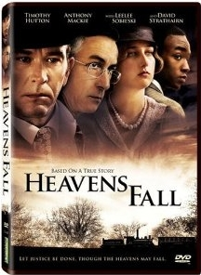
Daniel Anker and Barak Goodman produced the story of the Scottsboro Boys in the 2001 documentary Scottsboro: An American Tragedy, which received an Oscar nomination.

In the year 2006, a film titled 'Heavens Fall' has been made on this case. Its title has been borrowed from an old Latin Maxim, 'Fiat justitia, ruat coelun; meaning, 'Let justice be done, though heavens may fall'. The title befits the case.

Lord Denning in his autobiography 'The family Story' traces the origin of the legal maxim and comments that It was first used to excuse the most outrageous injustice. He says (page 171),
'It comes from a story told by Seneca. (Dialogues, III, 18) Piso sentenced a soldier to death for the murder of Gaius. He ordered a centurion to execute the sentence. When the soldier was about to be executed, Gaius came forward himself alive and well. The centurion reported it to Piso. He sentenced all three to death. The soldier because he had already been sentenced. The centurion for disobeying orders. And Gaius for being the cause of the death of two innocent men. Piso excused it by the plea, Fiat justitia, ruat coelum—Let justice be done, though the heavens should fall.

Afterwards Lord Mansfield used the same phrase in the celebrated case of John Wilkes: but he did it also with his tongue in his cheek. John Wilkes had published, so it was said, a seditious libel in a paper called The North Briton. He had fled abroad and been outlawed. He returned and himself asked for the outlawry to be reversed, but he was cast into prison meanwhile. He was a popular hero and many supported him and urged his release ... This is how Lord Mansfield answered them when he came to give judgement:
“The Constitution does not allow reasons of State to influence our judgements: God forbid it should! We must not regard political consequences, howsoever formidable they might be: if rebellion were the certain consequence, we are bound to say 'Fiat justitia, ruat coelum' ... We have no election ... We are to say, what we take the law to be: if we do not speak our real opinions, we prevaricate with God and our own consciences ... Once for all, let it be understood, that no endeavours of this kind will influence any man who at present sits here”.

Lord Mansfield went on to find a flaw … a most technical point. The sheriff had in the formal document referred to 'my county court' without adding the words 'of Middlesex' as he ought to have done―and for want of those two words the outlawry was held bad and John Wilkes was released. It would be lese-majeste to suggest that Lord Mansfield was influenced by the public clamour. But his audience knew not which to admire the more―the eloquence by which he silenced the people―or the subtlety by which he set their hero free.'

Lord Denning adds,
'For myself I prefer to take the first part―Fiat Justitia―and discard the 'ruat coelum'. If justice is done the heavens should not fall. They should rejoice.'

In the Scottsboro Boys trial―despite dissent by Chief Justice Aderson, overruling guilty verdict by the trial judge Horton, and twice setting aside conviction by the US Supreme Court twice―heavens did fall; they did not rejoice: it is commonly believed, that the Scottsboro Boys' were innocent of the rape charges.

Cotton gin is a machine that separates the seeds, seed hulls, and other small objects from the fibres of cotton.
See here http://www.law.umkc.edu/faculty/projects/FTrials/scottsboro/Batestestimony.html
See here http://www.law.umkc.edu/faculty/projects/FTrials/scottsboro/Exhorton.htm
Judge Horton was also defeated in re-election to the post. Unlike our country, some judges are elected in US.
The Attorney General of Alabama State appeared as the prosecuting counsel. His father was the judge in the Supreme Court of Alabama. It is said that he had influence there.
The conviction of Patterson was also set aside by the US Supreme Court in Patterson v. State of Alabama, 294 U.S. 600 (1935).

