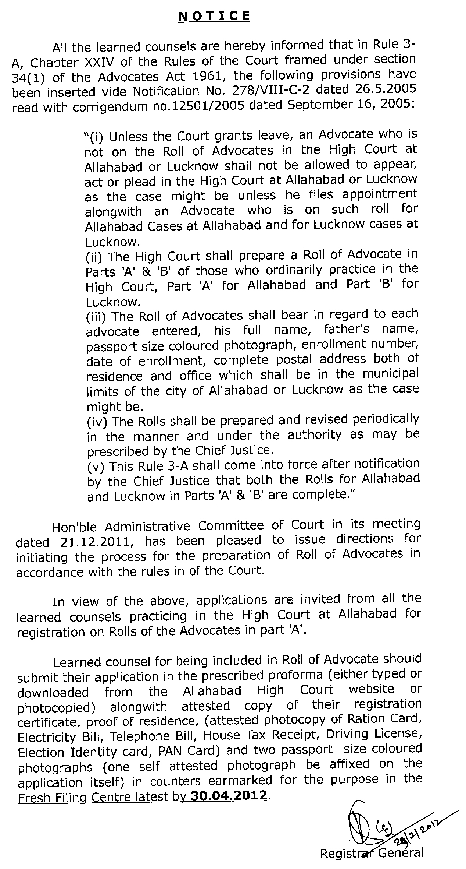
Application for registration on the Rolls of Advocates
practicing in the High Court at Allahabad.

Affix the self attested colour photograph with band

1. Full Name of the advocate :
(In capital letters)
- Father's/Husband's Name :
- Enrollment number
Year : State:
(Please attach attested copy of
registration certificate)
- Date of Enrollment :
- Complete address :
a) Residence :
(Please attach proof)
b) Office :
c) Chamber in the High Court:

- Telephone Numbers
a) Office :
b) Residence :
c) Mobile :
- E-Mail address, if any :
- Undertaking
I declare and undertake that I am practicing in this Hon'ble Court and that I have not made any applications anywhere else for listing my name on the Rolls of advocates except in this High Court. I further undertake that all the information mentioned above are correct to my personal knowledge and that the changes, if any, occurred therein, in the future, will be intimated, soon after, to the Registrar General.

Signature of the applicant

(Name and Date)

Note: Please also attach your two recent passport size coloured photos with band. One self–attested photo be pasted on the application itself while the second photo be unattested.

